# Meeting notes 4.02.2022

Initial Delirium & Sedation QIP clinic meeting

**Project title**

Delirium & sedation management in the ICU

**Lead**

Ronnie Marsh

**Present** **Absent**

Ronnie Marsh Dan Stein

Conor Foley David Egan

Tim Bonnici

Mel Tan (observing)

**Pre clinic questions**

Filled in: [see online form](https://docs.google.com/spreadsheets/d/1FiNg9aHonUBBJQ0ygpcTzNGSAkI9owMAOulDfLdT8_Q/edit?usp=sharing)

**Background**

Following on from the pain audit, Ronnie is now looking at our management of sedation and delirium in ICU. Once again the two main strands of questioning are:

1. measurement, and
2. response to abnormal scores

Ronnie is auditing against [this guideline](https://drive.google.com/file/d/1h8Vq-uJTDcyEwtdaI7GfRCfFJ9Go0Kpw/view?usp=sharing).

The key flowcharts are overleaf.

The presumption underlying Ronnie’s project is that we are not good at managing delirium and sedation in ICU.

* Best practice suggests that all patients should be maintained at a RASS of 0 or -1. Action should be taken to maintain a patient’s RASS in target range as per the guideline
* There is significant evidence to suggest that over-sedation in ICU causes harm
* Patients should be assessed for delirium regularly. When identified appropriate action should be taken to investigate reversible causes, remove them, and treat agitation only where necessary

The project focuses on two areas rather than one (delirium **and** sedation) because they should be assessed together.

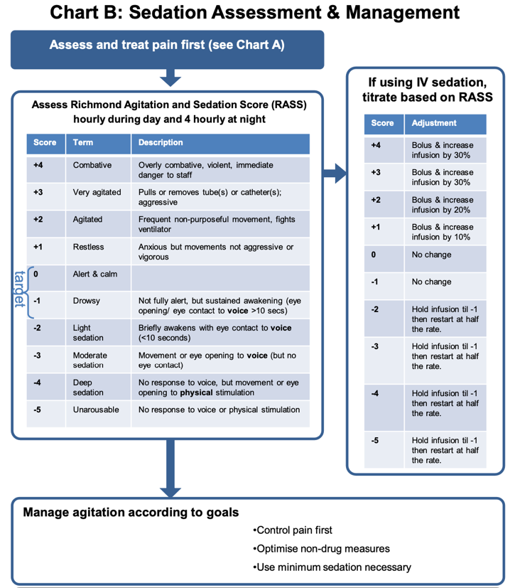

**Summary of project aims**

Aim:

Improve assessment and management of sedation and delirium in ICU

Strategy:

Measure current practices

Assess against local guideline

Qualitatively examine our practices

Questions:

Do we measure agitation/sedation appropriately?

Do we assess for delirium appropriately?

How do we act when level of sedation falls outside of the target range?

Are we assessing for reversible causes of delirium?

What are our behaviours administering medications for delirium?

**Summary of meeting minutes**

We discussed management of sedation and delirium, and discussed broadly around the audit topic.

While there are similarities with the pain project, we agreed this is more complex.

There are questions that can be answered with queryable data, but this will only be part of the answer.

All agreed this project would benefit from a qualitative/quantitative mixed methods approach.

**Agreed audit questions we will try to provide data for**:

We discussed that for some questions we will provide as close as we can to an answer with queryable data, and then for other questions we will provide an indication of patients of interest, whom Ronnie might want to qualitatively study.

**Inclusion criteria:**

All ICU admissions

Would Ronnie like to limit the time period? Or since start of Epic? Just as easy to compute, but perhaps less good a reflection of our current practice?

**Exclusion criteria:**

None

**Q1: Sedation. Are we measuring sedation appropriately?**

Source: flowsheets – RASS (id 3040104644)

flowsheets – ICU target RASS (from morning ward round) (id 36555)

Test: should be hourly in day shift, four hourly during night shift

Outputs:

i. number of measurements during stay

ii. number measurements / no. expected measurements (as per guideline)

Recorded results. This will help us identify patients of interest:

iii. time spent out of normal range – whether >0, or <-1

iv. time spent out of target range – pulled through from morning handover

**Q2: Sedation. Are we responding appropriately?**

This isn’t a question we will aim to provide a direct answer for: we discussed that this is not something we could easily, or reliably, answer from Caboodle. It’s better answered with qualitative data.

What we will aim to provide:

A cohort of patients who spent ≥24 hours outside the target range

Sedating drugs they were on

See list (next section)

Total daily dose?

Max infusion rate?

**Sedative medications (from Tim’s SQL)**

'331218' -- Propofol Volume

'331223' -- Fentanyl Volume

'12351' -- Clonidine Volume

'3040101250' -- Dexmedetomidine Volume

'3040101274' -- Midazolam Volume

'331228' -- Morphine Volume

'3040101304' -- Rocuronium

'3040105198' – Atracurium

**Q3: Delirium. Are we measuring appropriately?**

Source: flowsheets – CAM-ICU +ve / -ve. Note, these are calculated fields. See guideline.

'3040104645' -- CAM-ICU 1

'3040104647' -- CAM-ICU 2

'3040104648' -- CAM-ICU 3

'3040104649' -- CAM-ICU 4

'3040104650' -- CAM-ICU Total

Test: should be 8 hourly

Outputs:

i. number of measurements / number of expected measurements

Recorded results:

ii. number of positive results

**Q4: Delirium. Are we responding appropriately?**

Similar to **Q2**, this is difficult to provide data for. It is best answered qualitatively. The above data can provide patients to answer this.

We can however provide information on Olanzapine, Lorazepam, Midazolam and Haloperidol prescriptions for the above patients.

**Analysis**

Some element will be qualitative, and decided on by Ronnie.

It is likely some of the data we will provide would benefit from some light exploratory anaylsis by us in R. For example, an export of all RASS scores will be unwieldy (see Tim’s spreadsheet) and could be made much easier to deal with by some filtering.